Program : **B.Tech**

Subject Name: **Operating System**

Subject Code: **CS-405**

Semester: **4th**

## UNIT III

**Processes Concept** **Process**

A process is basically a program in execution. The execution of a process must progress in a sequential fashion.

A process is defined as an entity which represents the basic unit of work to be implemented in the system.

To put it in simple terms, we write our computer programs in a text file and when we execute this program, it becomes a process which performs all the tasks mentioned in the program.

When a program is loaded into the memory and it becomes a process, it can be divided into four sections ─ stack, heap, text and data. The following image shows a simplified layout of a process inside main memory

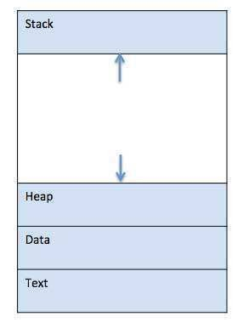

## Fig 3.1 Process

|  |  |
| --- | --- |
| **S.N.** | **Component & Description** |
| 1 | **Stack -** The process Stack contains the temporary data such as method/function parameters, return address and local variables. |
| 2 | **Heap -** This is dynamically allocated memory to a process during its run time. |
| 3 | **Text -** This includes the current activity represented by the value of Program Counter |

|  |  |
| --- | --- |
|  | and the contents of the processor's registers. |
| 4 | **Data -** This section contains the global and static variables. |

**Program**

A program is a piece of code which may be a single line or millions of lines. A computer program is usually written by a computer programmer in a programming language. For example, here is a simple program written in C programming language −

#include<stdio.h>

intmain () {

printf("Hello, World! \n"); return0;

}

A computer program is a collection of instructions that performs a specific task when executed by a computer. When we compare a program with a process, we can conclude that a process is a dynamic instance of a computer program.

A part of a computer program that perorms a well-defined task is known as an **algorithm**. A collection of computer programs, libraries and related data are referred to as software.

## Scheduling Concepts Definition

The process scheduling is the activity of the process manager that handles the removal of the running process from the CPU and the selection of another process on the basis of a particular strategy.

Process scheduling is an essential part of Multiprogramming operating systems. Such operating systems allow more than one process to be loaded into the executable memory at a time and the loaded process shares the CPU using time multiplexing.

## Process Scheduling Queues

The OS maintains all PCBs in Process Scheduling Queues. The OS maintains a separate queue for each of the process states and PCBs of all processes in the same execution state are placed in the same queue. When the state of a process is changed, its PCB is unlinked from its current queue and moved to its new state queue.

The Operating System maintains the following important process scheduling queues −

* **Job queue**− this queue keeps all the processes in the system.
* **Ready queue**− this queue keeps a set of all processes residing in main memory, ready and

waiting to execute. A new process is always put in this queue.



* **Device queues**− the processes which are blocked due to unavailability of an I/O device

constitute this queue.

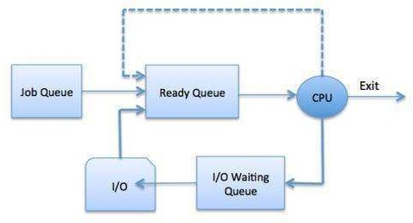

## Fig 3.2 Process Scheduling Queues

The OS can use different policies to manage each queue (FIFO, Round Robin, Priority, etc.). The OS scheduler determines how to move processes between the ready and run queues which can only have one entry per processor core on the system; in the above diagram, it has been merged with the CPU.

Two-State Process Model

Two-state process model refers to running and non-running states which are described below −

|  |  |
| --- | --- |
| **S.N.** | **State & Description** |
| 1 | **Running -** When a new process is created, it enters into the system as in the running state. |
| 2 | **Not Running -** Processes that are not running are kept in queue, waiting for their turn to execute. Each entry in the queue is a pointer to a particular process. Queue is implemented by using linked list. Use of dispatcher is as follows. When a process is interrupted, that process is transferred in the waiting queue. If the process has completed or aborted, the process is discarded. In either case, the dispatcher then selects a process from the queue to execute. |

## Types of Schedulers

Schedulers are special system software which handles process scheduling in various ways. Their main task is to select the jobs to be submitted into the system and to decide which process to run. Schedulers are of three types −

* Long-Term Scheduler
* Short-Term Scheduler
* Medium-Term Scheduler



## Long Term Scheduler

It is also called a **job scheduler**. A long-term scheduler determines which programs are admitted to the system for processing. It selects processes from the queue and loads them into memory for execution. Process loads into the memory for CPU scheduling.

The primary objective of the job scheduler is to provide a balanced mix of jobs, such as I/O bound and processor bound. It also controls the degree of multiprogramming. If the degree of multiprogramming is stable, then the average rate of process creation must be equal to the average departure rate of processes leaving the system.

On some systems, the long-term scheduler may not be available or minimal. Time-sharing operating systems have no long-term scheduler. When a process changes the state from new to ready, then there is use of long-term scheduler.

## Short Term Scheduler

It is also called as **CPU scheduler**. Its main objective is to increase system performance in accordance with the chosen set of criteria. It is the change of ready state to running state of the process. CPU scheduler selects a process among the processes that are ready to execute and allocates CPU to one of them.

Short-term schedulers, also known as dispatchers, make the decision of which process to execute next. Short-term schedulers are faster than long-term schedulers.

## Medium Term Scheduler

Medium-term scheduling is a part of **swapping**. It removes the processes from the memory. It reduces the degree of multiprogramming. The medium-term scheduler is in-charge of handling the swapped out-processes.

A running process may become suspended if it makes an I/O request. Suspended processes cannot make any progress towards completion. In this condition, to remove the process from memory and make space for other processes, the suspended process is moved to the secondary storage. This process is called **swapping**, and the process is said to be swapped out or rolled out. Swapping may be necessary to improve the process mix.

## Comparison among Scheduler

|  |  |  |  |
| --- | --- | --- | --- |
| **S.N.** | **Long-Term Scheduler** | **Short-Term Scheduler** | **Medium-Term Scheduler** |
| 1 | It is a job scheduler | It is a CPU scheduler | It is a process swapping scheduler. |
| 2 | Speed is lesser than short term scheduler | Speed is fastest among other two | Speed is in between both short and long term scheduler. |
| 3 | It controls the degree of multiprogramming | It provides lesser control over degree of multiprogramming | It reduces the degree of multiprogramming. |
| 4 | It is almost absent or minimal in time sharing | It is also minimal in time sharing system | It is a part of Time sharing systems. |

|  |  |  |  |
| --- | --- | --- | --- |
|  | system |  |  |
| 5 | It selects processes from pool and loads them into memory for execution | It selects those processes which are ready to execute | It can re-introduce the process into memory and execution can be continued. |

**Context Switch**

A context switch is the mechanism to store and restore the state or context of a CPU in Process Control block so that a process execution can be resumed from the same point at a later time. Using this technique, a context switcher enables multiple processes to share a single CPU. Context switching is an essential part of a multitasking operating system features.

When the scheduler switches the CPU from executing one process to execute another, the state from the current running process is stored into the process control block. After this, the state for the process to run next is loaded from its own PCB and used to set the PC, registers, etc. At that point, the second process can start executing.

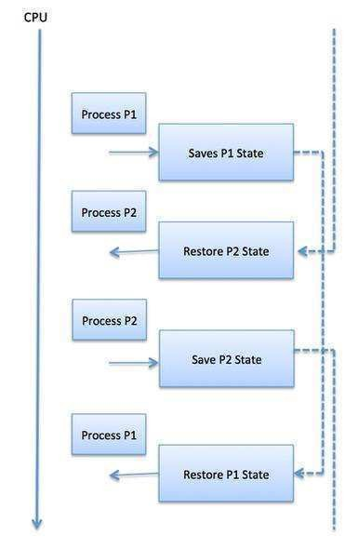

## Fig 3.3 Context Switch

Context switches are computationally intensive since register and memory state must be saved and restored. To avoid the amount of context switching time, some hardware systems employ two or more sets of processor registers. When the process is switched, the following information is stored for later use.

* Program Counter
* Scheduling information
* Base and limit register value
* Currently used register
* Changed State
* I/O State information
* Accounting information

## Process Life Cycle & Process State diagram

When a process executes, it passes through different states. These stages may differ in different operating systems, and the names of these states are also not standardized.

In general, a process can have one of the following five states at a time.

|  |  |
| --- | --- |
| **S.N.** | **State & Description** |
| 1 | **Start -** This is the initial state when a process is first started/ created. |
| 2 | **Ready -** The process is waiting to be assigned to a processor. Ready processes are waiting to have the processor allocated to them by the operating system so that they can run. Process may come into this state after **Start** state or while running it by but interrupted by the scheduler to assign CPU to some other process. |
| 3 | **Running -** Once the process has been assigned to a processor by the OS scheduler, the process state is set to running and the processor executes its instructions. |
| 4 | **Waiting -** Process moves into the waiting state if it needs to wait for a resource, such as waiting for user input, or waiting for a file to become available. |
| 5 | **Terminated or Exit -** Once the process finishes its execution, or it is terminated by the operating system, it is moved to the terminated state where it waits to be removed from main memory. |

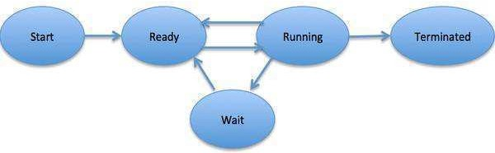

## Fig 3.4 Process State Diagram

**Process Control Block (PCB)**

A Process Control Block is a data structure maintained by the Operating System for every process. The PCB is identified by an integer process ID (PID). A PCB keeps all the information needed to keep track of a process as listed below in the table –

|  |  |
| --- | --- |
| **S.N.** | **Information & Description** |
| 1 | **Process State -** The current state of the process i.e., whether it is ready, running, waiting, or whatever. |
| 2 | **Process privileges -** This is required to allow/disallow access to system resources. |
| 3 | **Process ID -** Unique identification for each of the process in the operating system. |
| 4 | **Pointer -** A pointer to parent process. |
| 5 | **Program Counter -** Program Counter is a pointer to the address of the next instruction to be executed for this process. |
| 6 | **CPU registers -** Various CPU registers where process need to be stored for execution for running state. |
| 7 | **CPU Scheduling Information -** Process priority and other scheduling information which is required to schedule the process. |
| 8 | **Memory management information -** This includes the information of page table, memory limits, Segment table depending on memory used by the operating system. |
| 9 | **Accounting information -** This includes the amount of CPU used for process execution, time limits, execution ID etc. |
| 10 | **IO status information -** This includes a list of I/O devices allocated to the process. |

The architecture of a PCB is completely dependent on Operating System and may contain

different information in different operating systems. Here is a simplified diagram of a PCB −

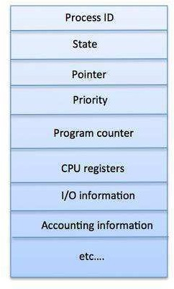

## Fig 3.5 Process Control Block (PCB)

The PCB is maintained for a process throughout its lifetime, and is deleted once the process terminates.

## Scheduling Algorithms

A Process Scheduler schedules different processes to be assigned to the CPU based on particular scheduling algorithms. There are six popular process scheduling algorithms

* Shortest-Job-Next (SJN) Scheduling
* Priority Scheduling
* Shortest Remaining Time
* Round Robin(RR) Scheduling
* Multiple-Level Queues Scheduling
* First-Come, First-Served (FCFS) Scheduling

These algorithms are either **non-preemptive or preemptive**. Non-preemptive algorithms are designed so that once a process enters the running state; it cannot be preempted until it completes its allotted time, whereas the preemptive scheduling is based on priority where a scheduler may preempt a low priority running process anytime when a high priority process enters into a ready state.

## First Come First Serve (FCFS)

* Jobs are executed on first come, first serve basis.
* It is a non-preemptive, pre-emptive scheduling algorithm.
* Easy to understand and implement.
* Its implementation is based on FIFO queue.
* Poor in performance as average wait time is high.

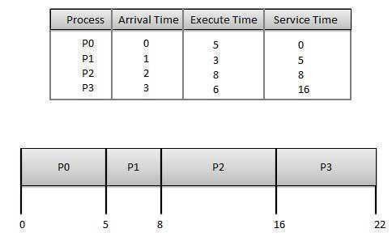

**Fig 3.6 First Come First Serve (FCFS) Wait time** of each process is as follows −

|  |  |
| --- | --- |
| **Process** | **Wait Time: Service Time - Arrival Time** |
| P0 | 0 - 0 = 0 |
| P1 | 5 - 1 = 4 |
| P2 | 8 - 2 = 6 |

|  |  |
| --- | --- |
| P3 | 16 - 3 = 13 |

Average Wait Time: (0+4+6+13) / 4 = 5.75

## Shortest Job Next (SJN)

* This is also known as **shortest job first**, or SJF
* This is a non-preemptive, pre-emptive scheduling algorithm.
* Best approach to minimize waiting time.
* Easy to implement in Batch systems where required CPU time is known in advance.
* Impossible to implement in interactive systems where required CPU time is not known.
* The processes should know in advance how much time process will take.

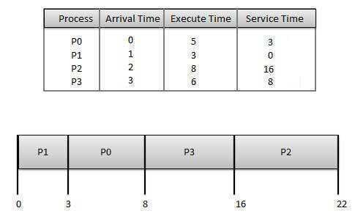

**Fig 3.7 Shortest Job Next (SJN) Wait time** of each process is as follows −

|  |  |
| --- | --- |
| **Process** | **Wait Time: Service Time - Arrival Time** |
| P0 | 3 - 0 = 3 |
| P1 | 0 - 0 = 0 |
| P2 | 16 - 2 = 14 |
| P3 | 8 - 3 = 5 |

Average Wait Time: (3+0+14+5) / 4 = 5.50

## Priority Based Scheduling

* Priority scheduling is a non-preemptive algorithm and one of the most common scheduling algorithms in batch systems.
* Each process is assigned a priority. Process with highest priority is to be executed first and so on.
* Processes with same priority are executed on first come first served basis.
* Priority can be decided based on memory requirements, time requirements or any other resource requirement.

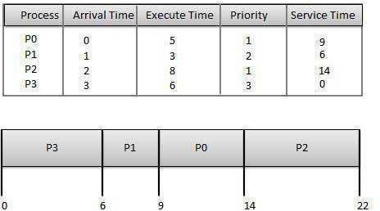

**Fig 3.8 Priority Based Scheduling Wait time** of each process is as follows −

|  |  |
| --- | --- |
| **Process** | **Wait Time: Service Time - Arrival Time** |
| P0 | 9 - 0 = 9 |
| P1 | 6 - 1 = 5 |
| P2 | 14 - 2 = 12 |
| P3 | 0 - 0 = 0 |

Average Wait Time: (9+5+12+0) / 4 = 6.5

## Shortest Remaining Time

* Shortest remaining time (SRT) is the preemptive version of the SJN algorithm.
* The processor is allocated to the job closest to completion but it can be preempted by a newer ready job with shorter time to completion.
* Impossible to implement in interactive systems where required CPU time is not known.
* It is often used in batch environments where short jobs need to give preference.

## Round Robin Scheduling

* Round Robin is the preemptive process scheduling algorithm.
* Each process is provided a fix time to execute, it is called a **quantum**.
* Once a process is executed for a given time period, it is preempted and other process executes for a given time period.
* Context switching is used to save states of preempted processes.

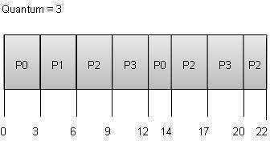

**Fig 3.9 Round Robin Scheduling Wait time** of each process is as follows −

|  |  |
| --- | --- |
| **Process** | **Wait Time: Service Time - Arrival Time** |
| P0 | (0 - 0) + (12 - 3) = 9 |
| P1 | (3 - 1) = 2 |
| P2 | (6 - 2) + (14 - 9) + (20 - 17) = 12 |
| P3 | (9 - 3) + (17 - 12) = 11 |

Average Wait Time: (9+2+12+11) / 4 = 8.5

## Multiple-Level Queues Scheduling

Multiple-level queues are not an independent scheduling algorithm. They make use of other existing algorithms to group and schedule jobs with common characteristics.

* Multiple queues are maintained for processes with common characteristics.
* Each queue can have its own scheduling algorithms.
* Priorities are assigned to each queue.

For example, CPU-bound jobs can be scheduled in one queue and all I/O-bound jobs in another queue. The Process Scheduler then alternately selects jobs from each queue and assigns them to the CPU based on the algorithm assigned to the queue.

## Algorithm Evaluation

How do we select a CPU scheduling algorithm for a particular system?

There are many scheduling algorithms, each with its own parameters. As a result, selecting an algorithm can be difficult. The first problem is defining the criteria to be used in selecting an algorithm. Criteria are often defined in terms of CPU utilization, response time, or throughput. To select an algorithm, we must first define the relative importance of these measures. Our criteria may include several measures, such as:

* + Maximizing CPU utilization under the constraint that the maximum response time is 1 second
  + Maximizing throughput such that turnaround time is (on average) linearly proportional to total execution time once the selection criteria have been defined, we want to evaluate the algorithms under consideration. We next describe the various evaluation methods we can use.

## Deterministic Modeling

One major class of evaluation methods is analytic evaluation. Analytic evaluation uses the given algorithm and the system workload to produce a formula or number that evaluates the performance of the algorithm for that workload. One type of analytic evaluation is deterministic modeling. This method takes a particular predetermined workload and defines the performance of each algorithm for that workload. For example, assume that we have the workload shown below. All five processes arrive at time 0, in the order given, with the length of the CPU burst given in milliseconds:

## Queuing Models

Another method of evaluating scheduling algorithms is to use queuing theory. Using data from real processes we can arrive at a probability distribution for the length of a burst time and the I/O times for a process. We can now generate these times with a certain distribution.

We can also generate arrival times for processes (arrival time distribution).

If we define a queue for the CPU and a queue for each I/O device we can test the various scheduling algorithms using queuing theory.

Knowing the arrival rates and the service rates we can calculate various figures such as average queue length, average wait time, CPU utilization etc.

One useful formula is L**ittle’s Formula.**

n = λw

Where

n is the average queue length

λ is the average arrival rate for new processes (e.g. five a second) w is the average waiting time in the queue

Knowing two of these values we can, obviously, calculate the third. For example, if we know that eight processes arrive every second and there are normally sixteen processes in the queue we can compute that the average waiting time per process is two seconds.

The main disadvantage of using queuing models is that it is not always easy to define realistic distribution times and we have to make assumptions. This results in the model only being an approximation of what actually happens.

## Simulations

Rather than using queuing models we simulate a computer. A Variable, representing a clock is incremented. At each increment the state of the simulation is updated.

Statistics are gathered at each clock tick so that the system performance can be analyzed.

The data to drive the simulation can be generated in the same way as the queuing model, although this leads to similar problems.

Alternatively, we can use trace data. This is data collected from real processes on real [machines](https://be.rgpvnotes.in/) and is fed into the simulation. This can often provide good results and good comparisons over a range of scheduling algorithms.

However, simulations can take a long time to run, can take a long time to implement and the trace data may be difficult to collect and require large amounts of storage.

## Implementation

The best way to compare algorithms is to implement them on real machines. This will give the best results but does have a number of disadvantages.

* + It is expensive as the algorithm has to be written and then implemented on real hardware.
  + If typical workloads are to be monitored, the scheduling algorithm must be used in a live situation. Users may not be happy with an environment that is constantly changing.
  + If we find a scheduling algorithm that performs well there is no guarantee that this state will continue if the workload or environment changes.

## System Calls for Process Management

Basic process management is done with a number of system calls, each with a single (simple) purpose. These system calls can then be combined to implement more complex behaviors.

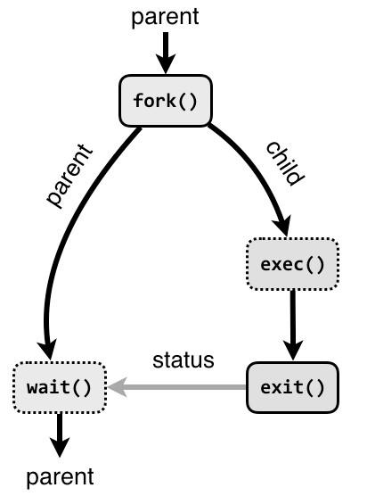

## Fig: 3.10 System Calls for Process Management

The following system calls are used for basic process management.

* + **fork :**A parent process uses fork to create a new child process. The child process is a copy of the parent. After fork, both parent and child executes the same program but in separate processes.
  + **exec:** Replaces the program executed by a process. The child may use exec after a fork to replace the process’ memory space with a new program executable making the child execute a different program than the parent.
  + **exit:** Terminates the process with an exit status.
  + **wait:** The parent may use wait to suspend execution until a child terminates. Using wait the parent can obtain the exit status of a terminated child.

## Multiple Processor Schedulers:

In multiple-processor scheduling **multiple CPU’s** are available and hence **Load Sharing** becomes possible. However multiple processor scheduling is more **complex** as compared to single processor scheduling. In multiple processor scheduling there are cases when the processors are identical i.e. HOMOGENEOUS, in terms of their functionality; we can use any processor available to run any process in the queue.

## Approaches to Multiple-Processor Scheduling

One approach is when all the scheduling decisions and I/O processing are handled by a single processor which is called the Master Server and the other processors executes only the user code. This is simple and reduces the need of data sharing. This entire scenario is called Asymmetric Multiprocessing.



A second approach uses Symmetric Multiprocessing where each processor is self scheduling. All processes may be in a common ready queue or each processor may have its own private queue for ready processes. The scheduling proceeds further by having the scheduler for each processor examine the ready queue and select a process to execute.

## Processor Affinity

Processor Affinity means a process has an affinity for the processor on which it is currently running. When a process runs on a specific processor there are certain effects on the cache memory. The data most recently accessed by the process populate the cache for the processor and as a result successive memory accesses by the process are often satisfied in the cache memory. Now if the process migrates to another processor, the contents of the cache memory must be invalidated for the first processor and the cache for the second processor must be repopulated. Because of the high cost of invalidating and repopulating caches, most of the SMP(symmetric multiprocessing) systems try to avoid migration of processes from one processor to another and try to keep a process running on the same processor. This is known as **PROCESSOR AFFINITY**.

* + **Soft Affinity –** When an operating system has a policy of attempting to keep a process running on the same processor but not guaranteeing it will do so, this situation is called soft affinity.
  + **Hard Affinity –** Some systems such as Linux also provide some system calls that support Hard Affinity which allows a process to migrate between processors.

## Thread

A thread is a flow of execution through the process code, with its own program counter that keeps track of which instruction to execute next, system registers which hold its current working variables, and a stack which contains the execution history.

A thread shares with its peer threads little information like code segment, data segment and open files. When one thread alters a code segment memory item, all other threads see that.

A thread is also called a **lightweight process**. Threads provide a way to improve application performance through parallelism. Threads represent a software approach to improving performance of operating system by reducing the overhead thread is equivalent to a classical process.

Each thread belongs to exactly one process and no thread can exist outside a process. Each thread represents a separate flow of control. Threads have been successfully used in implementing network servers and web server. They also provide a suitable foundation for parallel execution of applications on shared memory multiprocessors. The following figure shows the working of a single-threaded and a multithreaded process.

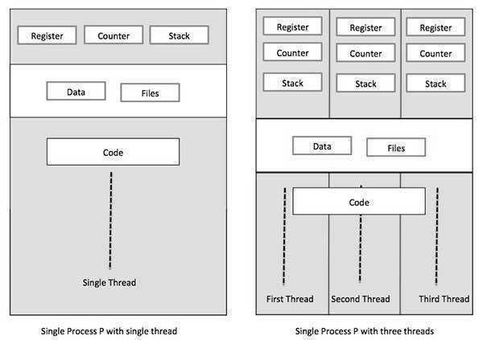

## Fig 3.11 Thread Fig 3.12 Thread

**Difference between Process and Thread**

|  |  |  |
| --- | --- | --- |
| **S.N.** | **Process** | **Thread** |
| 1 | Process is heavy weight or resource intensive. | Thread is light weight, taking lesser resources than a process. |
| 2 | Process switching needs interaction with operating system. | Thread switching does not need to interact with operating system. |
| 3 | In multiple processing environments, each process executes the same code but has its own memory and file resources. | All threads can share same set of open files, child processes. |
| 4 | If one process is blocked, then no other process can execute until the first process is unblocked. | While one thread is blocked, and waiting, a second thread in the same task can run. |
| 5 | Multiple processes without using threads use more resources. | Multiple threaded processes use fewer resources. |
| 6 | In multiple processes, each process operates independently of the others. | One thread can read, write or change another thread's data. |

## Advantages of Thread

* Threads minimize the context switching time.
* Use of threads provides concurrency within a process.
* Efficient communication.
* It is more economical to create and context switch threads.
* Threads allow utilization of multiprocessor architectures to a greater scale and efficiency.

## Types of Thread

Threads are implemented in following two ways −

* **User Level Threads**− User managed threads.
* **Kernel Level Threads**− Operating System managed threads acting on kernel, an operating

system core.

## User Level Threads

In this case, the thread management kernel is not aware of the existence of threads. The thread library contains code for creating and destroying threads, for passing message and data between threads, for scheduling thread execution and for saving and restoring thread contexts. The application starts with a single thread.

## Advantages



**Fig 3.13 User Level Threads**

* Thread switching does not require Kernel mode privileges.
* User level thread can run on any operating system.
* Scheduling can be application specific in the user level thread.
* User level threads are fast to create and manage.

## Disadvantages

* In a typical operating system, most system calls are blocking.
* Multithreaded application cannot take advantage of multiprocessing.

## Kernel Level Threads

In this case, thread management is done by the Kernel. There is no thread management code in the application area. Kernel threads are supported directly by the operating system. Any application can be programmed to be multithreaded. All of the threads within an application are supported within a single process.

The Kernel maintains context information for the process as a whole and for individual’s threads within the process. Scheduling by the Kernel is done on a thread basis. The Kernel performs thread creation, scheduling and management in Kernel space. Kernel threads are generally slower to create and manage than the user threads.

## Advantages

* Kernel can simultaneously schedule multiple threads from the same process on multiple processes.
* If one thread in a process is blocked, the Kernel can schedule another thread of the same process.
* Kernel routines themselves can be multithreaded.

## Disadvantages

* Kernel threads are generally slower to create and manage than the user threads.
* Transfer of control from one thread to another within the same process requires a mode switch to the Kernel.

## Multithreading Models

Some operating system provides a combined user level thread and Kernel level thread facility. Solaris is a good example of this combined approach. In a combined system, multiple threads within the same application can run in parallel on multiple processors and a blocking system call need not block the entire process. Multithreading models are three types

* Many too many relationships.
* Many to one relationship.
* One to one relationship.

## Many too Many Model

The many-to-many model multiplexes any number of user threads onto an equal or smaller number of kernel threads.

The following diagram shows the many-to-many threading model where 6 user level threads are multiplexing with 6 kernel level threads. In this model, developers can create as many user threads as necessary and the corresponding Kernel threads can run in parallel on a multiprocessor machine. This model provides the best accuracy on concurrency and when a thread performs a blocking system call, the kernel can schedule another thread for execution.

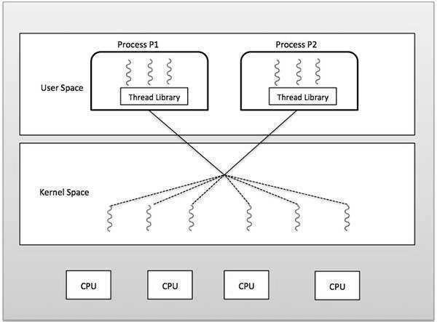

## Fig 3.14 Many too Many Model

**Many to One Model**

Many-to-one model maps many user level threads to one Kernel-level thread. Thread management is done in user space by the thread library. When thread makes a blocking system call, the entire process will be blocked. Only one thread can access the Kernel at a time, so multiple threads are unable to run in parallel on multiprocessors.

If the user-level thread libraries are implemented in the operating system in such a way that the system does not support them, then the Kernel threads use the many-to-one relationship modes.

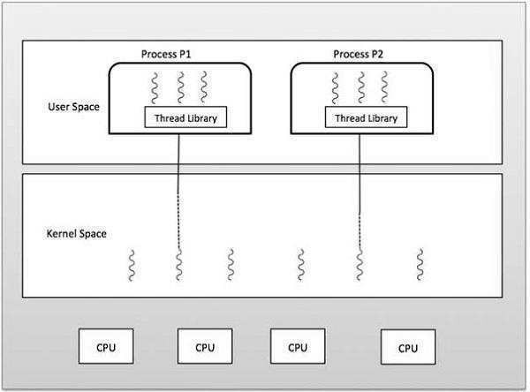

## Fig 3.15 Many to One Model

**One to One Model**

There is one-to-one relationship of user-level thread to the kernel-level thread. This model provides more concurrency than the many-to-one model. It also allows another thread to run when a thread makes a blocking system call. It supports multiple threads to execute in parallel on microprocessors.

Disadvantage of this model is that creating user thread requires the corresponding Kernel thread. OS/2, Windows NT and windows 2000 use one to one relationship model.

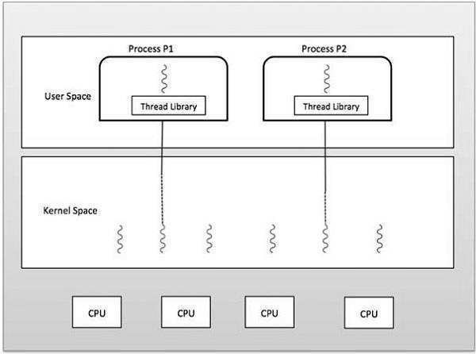

## Fig 3.16 One to One Model Difference between User-Level & Kernel-Level Thread

|  |  |  |
| --- | --- | --- |
| **S.N.** | **User-Level Threads** | **Kernel-Level Thread** |
| 1 | User-level threads are faster to create and manage. | Kernel-level threads are slower to create and manage. |
| 2 | Implementation is by a thread library at the user level. | Operating system supports creation of Kernel threads. |
| 3 | User-level thread is generic and can run on any operating system. | Kernel-level thread is specific to the operating system. |
| 4 | Multi-threaded applications cannot take advantage of multiprocessing. | Kernel routines themselves can be multithreaded. |

**Memory Management**

Memory management is the functionality of an operating system which handles or manages primary memory and moves processes back and forth between main memory and disk during execution. Memory management keeps track of each and every memory location, regardless of either it is allocated to some process or it is free. It checks how much memory is to be allocated to processes. It decides which process will get memory at what time. It tracks whenever some memory gets freed or unallocated and correspondingly it updates the status.

## Process Address Space

The process address space is the set of logical addresses that a process references in its code. For example, when 32-bit addressing is in use, addresses can range from 0 to 0x7fffffff; that is, 2^31 possible numbers, for a total theoretical size of 2 gigabytes.

The operating system takes care of mapping the logical addresses to physical address[es at the](https://be.rgpvnotes.in/) time of memory allocation to the program. There are three types of addresses used in a program before and after memory is allocated −

|  |  |
| --- | --- |
| **S.N.** | **Memory Addresses & Description** |
| 1 | **Symbolic addresses -** The addresses used in a source code. The variable names, constants, and instruction labels are the basic elements of the symbolic address space. |
| 2 | **Relative addresses -** At the time of compilation, a compiler converts symbolic addresses into relative addresses. |
| 3 | **Physical addresses -** The loader generates these addresses at the time when a program is loaded into main memory. |

**Virtual and physical addresses** are the same in compile-time and load-time address-binding schemes. Virtual and physical addresses differ in execution-time address-binding scheme.

The set of all logical addresses generated by a program is referred to as a **logical address space**. The set of all physical addresses corresponding to these logical addresses is referred to as a **physical address space.**

The runtime mapping from virtual to physical address is done by the memory management unit (MMU) which is a hardware device. MMU uses following mechanism to convert virtual address to physical address.

* The value in the base register is added to every address generated by a user process, which is treated as offset at the time it is sent to memory. For example, if the base register value is 10000, then an attempt by the user to use address location 100 will be dynamically reallocated to location 10100.
  + The user program deals with virtual addresses; it never sees the real physical addresses.

## Memory Allocation (Partitioning)

Main memory usually has two partitions −

* + **Low Memory**− Operating system resides in this memory.
  + **High Memory**− User processes are held in high memory.

Operating system uses the following memory allocation mechanism.

|  |  |
| --- | --- |
| **S.N.** | **Memory Allocation & Description** |
| 1 | **Single-partition allocation -** In this type of allocation, relocation-register scheme is used to protect user processes from each other, and from changing operating- system code and data. Relocation register contains value of smallest physical address whereas limit register contains range of logical addresses. Each logical address must be less than the limit register. |
| 2 | **Multiple-partition allocation -** In this type of allocation, main memory is divided into a number of fixed-sized partitions where each partition should contain only one process. When a partition is free, a process is selected from the input queue  and is loaded into the free partition. When the process terminates, the partition |



|  |  |
| --- | --- |
|  | becomes available for another process. |

## Fragmentation

As processes are loaded and removed from memory, the free memory space is broken into little pieces. It happens after sometimes that processes cannot be allocated to memory blocks considering their small size and memory blocks remains unused. This problem is known as Fragmentation.

Fragmentation is of two types –

|  |  |
| --- | --- |
| **S.N.** | **Fragmentation & Description** |
| 1 | **External fragmentation -** Total memory space is enough to satisfy a request or to reside a process in it, but it is not contiguous, so it cannot be used. |
| 2 | **Internal fragmentation -** Memory block assigned to process is bigger. Some portion of memory is left unused, as it cannot be used by another process. |

The following diagram shows how fragmentation can cause waste of memory and a compaction technique can be used to create more free memory out of fragmented memory −

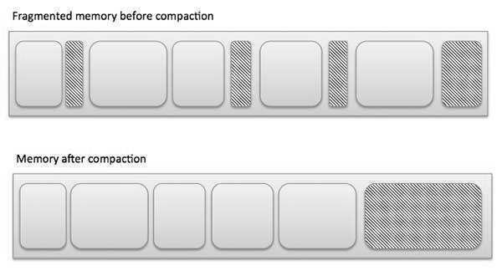

## Fig 3.17 Fragmentation

**External fragmentation** can be reduced by compaction or shuffle memory contents to place all free memory together in one large block. To make compaction feasible, relocation should be dynamic.

**The internal fragmentation** can be reduced by effectively assigning the smallest partition but large enough for the process.

## Swapping

Swapping is mechanisms in which a process can be swapped temporarily out of main memory (or move) to secondary storage (disk) and make that memory available to other processes. At

some later time, the system swaps back the process from the secondary storage [to main](https://be.rgpvnotes.in/) memory.

Though performance is usually affected by swapping process but it helps in running multiple and big processes in parallel and that's the reason. **Swapping is also known as a technique for memory compaction**.

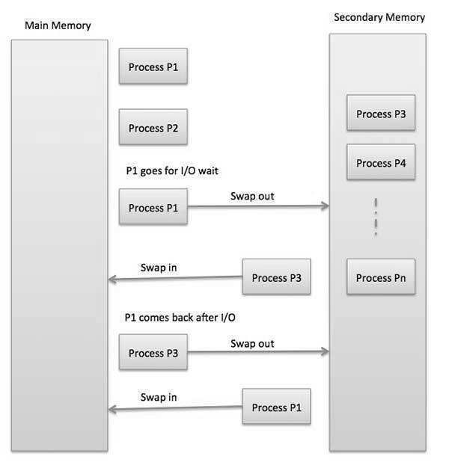

## Fig 3.18 Swapping

The total time taken by swapping process includes the time it takes to move the entire process to a secondary disk and then to copy the process back to memory, as well as the time the process takes to regain main memory.

Let us assume that the user process is of size 2048KB and on a standard hard disk where swapping will take place has a data transfer rate around 1 MB per second. The actual transfer of the 1000K process to or from memory will take

2048KB / 1024KB per second

= 2 seconds

= 2000 milliseconds

Now considering in and out time, it will take complete 4000 milliseconds plus other overhead where the process competes to regain main memory.

## Paging

A computer can address more memory than the amount physically installed on the system. This extra memory is actually called virtual memory and it is a section of a hard that's set up to emulate the computer's RAM. Paging technique plays an important role in implementing virtual memory.

Paging is a memory management technique in which process address space is broken into blocks of the same size called **pages** (size is power of 2, between 512 bytes and 8192 bytes). The size of the process is measured in the number of pages.

Similarly, main memory is divided into small fixed-sized blocks of (physical) memory called **frames** and the size of a frame is kept the same as that of a page to have optimum utilization of the main memory and to avoid external fragmentation.

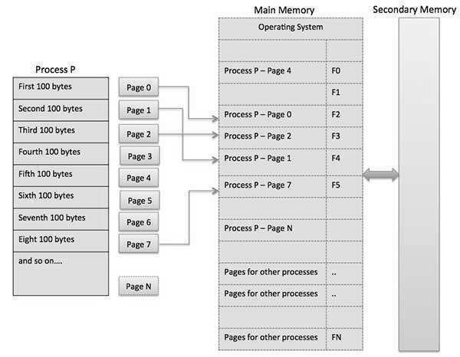

## Fig 3.19 Paging

**Address Translation**

Page address is called **logical address** and represented by **page number** and the **offset**.

Frame address is called **physical address** and represented by a **frame number** and the **offset**.

Physical Address = Frame number + page offset

A data structure called **page map table** is used to keep track of the relation between a pages of a process to a frame in physical memory.

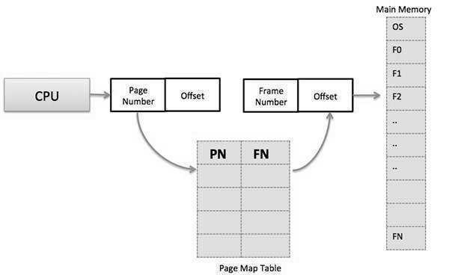

## Fig 3.20 Address Translation

When the system allocates a frame to any page, it translates this logical address into a physical address and creates entry into the page table to be used throughout execution of the program.

When a process is to be executed, its corresponding pages are loaded into any available memory frames. Suppose you have a program of 8Kb but your memory can accommodate only 5Kb at a given point in time, then the paging concept will come into picture. When a computer runs out of RAM, the operating system (OS) will move idle or unwanted pages of memory to secondary memory to free up RAM for other processes and brings them back when needed by the program.

This process continues during the whole execution of the program where the OS keeps removing idle pages from the main memory and write them onto the secondary memory and bring them back when required by the program.

## Advantages and Disadvantages of Paging

* + Paging reduces external fragmentation, but still suffers from internal fragmentation.
  + Paging is simple to implement and assumed as an efficient memory management technique.
  + Due to equal size of the pages and frames, swapping becomes very easy.
  + Page table requires extra memory space, so may not be good for a system having small RAM.

## Segmentation

Segmentation is a memory management technique in which each job is divided into several segments of different sizes, one for each module that contains pieces that perform related functions. Each segment is actually a different logical address space of the program.

When a process is to be executed, its corresponding segmentation is loaded into non- contiguous memory though every segment is loaded into a contiguous block of available memory.

Segmentation memory management works very similar to paging but here segments are of variable-length where as in paging pages are of fixed size.

A program segment contains the program's main function, utility functions, data structures, and so on. The operating system maintains a **segment map table** for every process and a list of free memory blocks along with segment numbers, their size and corresponding memory locations in main memory. For each segment, the table stores the starting address of the segment and the length of the segment. A reference to a memory location includes a value that identifies a segment and an offset.

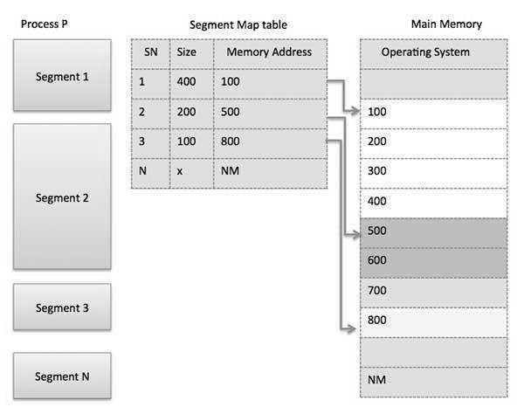

## Fig 3.21 Segmentation

**Segmented Paging**

Pure segmentation is not very popular and not being used in many of the operating systems. However, Segmentation can be combined with Paging to get the best features out of both the techniques.

In Segmented Paging, the main memory is divided into variable size segments which ar[e further](https://be.rgpvnotes.in/) divided into fixed size pages.

1. Pages are smaller than segments.
2. Each Segment has a page table which means every program has multiple page tables.
3. The logical address is represented as Segment Number (base address), Page number and page offset.

**Segment Number →** It points to the appropriate Segment Number. **Page Number →** It Points to the exact page within the segment **Page Offset →** Used as an offset within the page frame

Each Page table contains the various information about every page of the segment. The Segment Table contains the information about every segment. Each segment table entry points to a page table entry and every page table entry is mapped to one of the page within a segment.

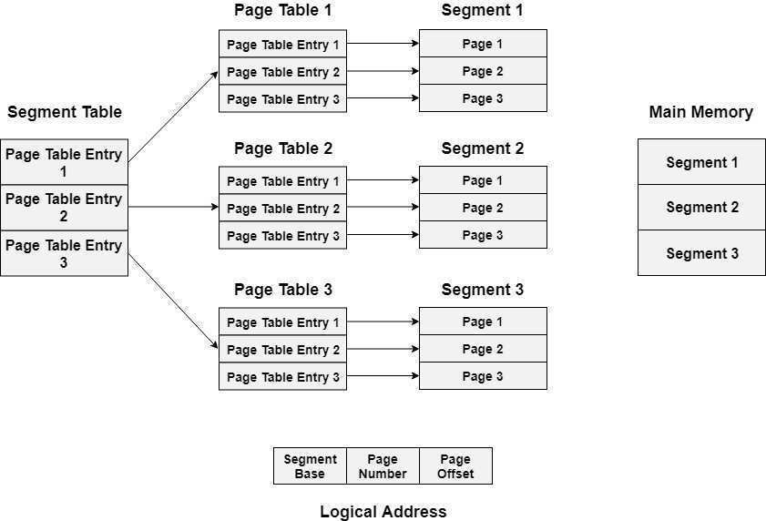

## Fig. 3.22 Segmented Paging Translation of logical address to physical address

The CPU generates a logical address which is divided into two parts: Segment Number and Segment Offset. The Segment Offset must be less than the segment limit. Offset is further divided into Page number and Page Offset. To map the exact page number in the page table, the page number is added into the page table base.

The actual frame number with the page offset is mapped to the main memory to get th[e](https://be.rgpvnotes.in/) desired word in the page of the certain segment of the process.

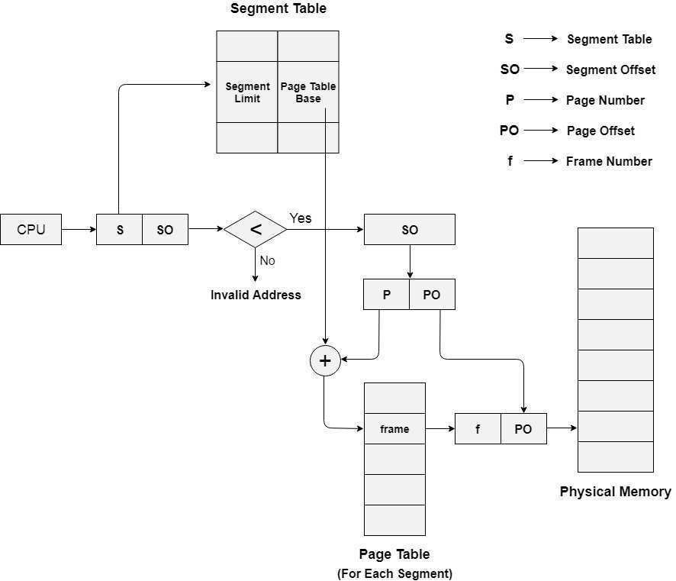

## Fig. 3.23 Translation of logical address to physical address Advantages of Segmented Paging

1. It reduces memory usage.
2. Page table size is limited by the segment size.
3. Segment table has only one entry corresponding to one actual segment.
4. External Fragmentation is not there.
5. It simplifies memory allocation.

Disadvantages of Segmented Paging

1. Internal Fragmentation will be there.
2. The complexity level will be much higher as compare to paging.
3. Page Tables need to be contiguously stored in the memory.

## Comparison between Paging and Segmentation technique

|  |  |  |
| --- | --- | --- |
| **Sr. No.** | **Paging** | **Segmentation** |
| 1 | A page is a physical unit of information. | A segment is a logical unit of information. |
| 2 | A page is invisible to the user's program. | A segment is visible to the user's program. |
| 3 | A page is of fixed size e.g. 4Kbytes. | A segment is of varying size. |
| 4 | The page size is determined by the machine architecture. | A segment size is determined by the user. |
| 5 | Fragmentation may occur. | Segmentation eliminates fragmentation. |
| 6 | Page frames on main memory are required. | No frames are required. |

**Technique for Execution of large Programs: Overlay:**

The main problem in fixed partitioning is the size of a process has to be limited by the maximum size of the partition, which means a process can never be span over another. In order to solve this problem, earlier people have used some solution which is called as Overlays.



The concept of **overlays** is that whenever a process is running it will not use the complete program at the same time, it will use only some part of it. Then overlays concept says that whatever part you required, you load it an once the part is done, then you just unload it, means just pull it back and get the new part you required and run it.

“The process of **transferring a block** of program code or other data into internal memory,

replacing what is already stored”.

Sometimes it happens that compare to the size of the biggest partition, the size of the program will be even more, then, in that case, you should go with overlays. So overlay is a technique to run a program that is bigger than the size of the physical memory by keeping only those instructions and data that are needed at any given time. Divide the program into modules in such a way that not all modules need to be in the memory at the same time.

## Advantage –

* + Reduce memory requirement
  + Reduce time requirement

## Disadvantage –

* + Overlap map must be specified by programmer
  + Programmer must know memory requirement
  + Overlapped module must be completely disjoint
  + Programming design of overlays structure is complex and not possible in all cases

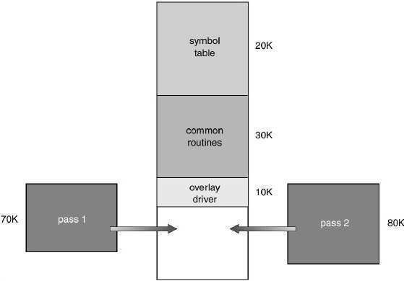

## Fig 3.24 Overlays for two pas Assembler

**Static vs Dynamic Loading**

The choice between Static or Dynamic Loading is to be made at the time of computer program being developed. If you have to load your program statically, then at the time of compilation, the complete programs will be compiled and linked without leaving any external program or module dependency. The linker combines the object program with other necessary object modules into an absolute program, which also includes logical addresses.

If you are writing a dynamically loaded program, then your compiler will compile the program and for all the modules which you want to include dynamically, only references will be provided and rest of the work will be done at the time of execution.

At the time of loading, with **static loading**, the absolute program (and data) is loaded into memory in order for execution to start.

If you are using **dynamic loading**, dynamic routines of the library are stored on a disk in relocatable form and are loaded into memory only when they are needed by the program.

## Static vs Dynamic Linking

As explained above, when static linking is used, the linker combines all other modules needed by a program into a single executable program to avoid any runtime dependency.

When dynamic linking is used, it is not required to link the actual module or library with the program, rather a reference to the dynamic module is provided at the time of compilation and linking. Dynamic Link Libraries (DLL) in Windows and Shared Objects in UNIX are good examples of dynamic libraries.

## Virtual Memory

A computer can address more memory than the amount physically installed on the system. This extra memory is actually called **virtual memory** and it is a section of a hard disk that's set up to emulate the computer's RAM.

The main visible advantage of this scheme is that programs can be larger than physical memory. Virtual memory serves two purposes. First, it allows us to extend the use of physical memory by using disk. Second, it allows us to have memory protection, because each virtual address is translated to a physical address.

Following are the situations, when entire program is not required to be loaded fully in main memory.

* + User written error handling routines are used only when an error occurred in the data or computation.
  + Certain options and features of a program may be used rarely.
  + Many tables are assigned a fixed amount of address space even though only a small amount of the table is actually used.
  + The ability to execute a program that is only partially in memory would counter many benefits.
  + Less number of I/O would be needed to load or swap each user program into memory.
  + A program would no longer be constrained by the amount of physical memory that is available.
  + Each user program could take less physical memory; more programs could be run the same time, with a corresponding increase in CPU utilization and throughput.

Modern microprocessors intended for general-purpose use, a memory management unit, or MMU, is built into the hardware. The MMU's job is to translate virtual addresses into physical addresses. A basic example is given below −

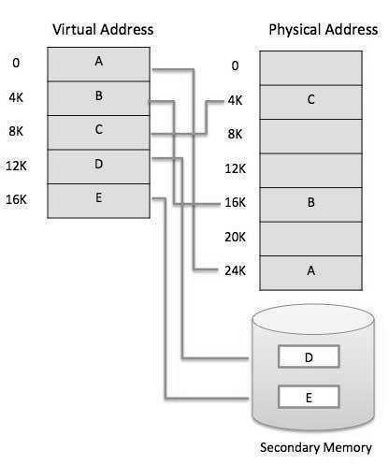

## Fig 3.25 Virtual Memory

**Virtual memory** is commonly implemented by demand paging. It can also be implemented in a segmentation system. Demand segmentation can also be used to provide virtual memory.

## Demand Paging

A demand paging system is quite similar to a paging system with swapping where processes reside in secondary memory and pages are loaded only on demand, not in advance. When a context switch occurs, the operating system does not copy any of the old program’s pages out to the disk or any of the new program’s pages into the main memory Instead, it just begins executing the new program after loading the first page and fetches that program’s pages as they are referenced.

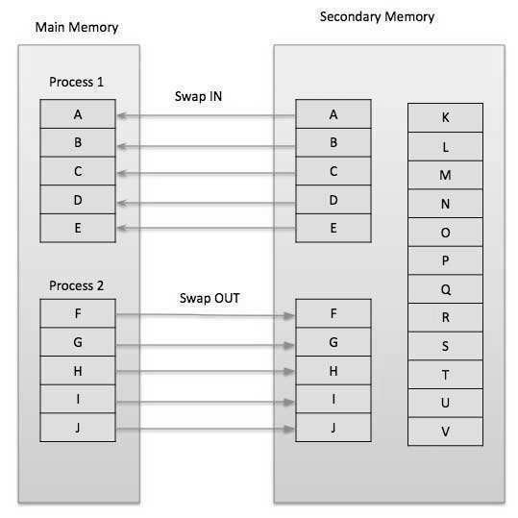

## Fig 3.26 Demand Paging

While executing a program, if the program references a page which is not available in the main memory because it was swapped out a little ago, the processor treats this invalid memory reference as a **page fault** and transfers control from the program to the operating system to demand the page back into the memory.

## Advantages

* + Large virtual memory.
  + More efficient use of memory.
  + There is no limit on degree of multiprogramming.

## Disadvantages

* + Number of tables and the amount of processor overhead for handling page interrupts are greater than in the case of the simple paged management techniques.

## Page Replacement Algorithm

Page replacement algorithms are the techniques using which an Operating System decides which memory pages to swap out, write to disk when a page of memory needs to be allocated. Paging happens whenever a page fault occurs and a free page cannot be used for allocation purpose accounting to reason that pages are not available or the number of free pages is lower than required pages.

When the page that was selected for replacement and was paged out, is referenced again, it has to read in from disk, and this requires for I/O completion. This process determines the quality of the page replacement algorithm: the lesser the time waiting for page-ins, the better is the algorithm.

A page replacement algorithm looks at the limited information about accessing the pages provided by hardware, and tries to select which pages should be replaced to minimize the total number of page misses, while balancing it with the costs of primary storage and processor time of the algorithm itself. There are many different page replacement algorithms. We evaluate an algorithm by running it on a particular string of memory reference and computing the number of page faults,

Reference String

The string of memory references is called reference string. Reference strings are generated artificially or by tracing a given system and recording the address of each memory reference. The latter choice produces a large number of data, where we note two things.

* + - For a given page size, we need to consider only the page number, not the entire address.
    - If we have a reference to a page **p**, then any immediately following references to page **p** will never cause a page fault. Page p will be in memory after the first reference; the immediately following references will not fault.
    - For example, consider the following sequence of addresses − 123,215,600,1234,76,96
    - If page size is 100, then the reference string is 1,2,6,12,0,0

## First in First out (FIFO) algorithm

* + Oldest page in main memory is the one which will be selected for replacement.
  + Easy to implement, keep a list, replace pages from the tail and add new pages at the head.

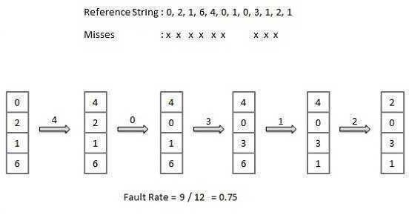

## Fig 3.27 First in First out (FIFO) algorithm

**Optimal Page algorithm**

* + An optimal page-replacement algorithm has the lowest page-fault rate of all algorithms. An optimal page-replacement algorithm exists, and has been called OPT or MIN.
  + Replace the page that will not be used for the longest period of time. Use the time when a page is to be used.

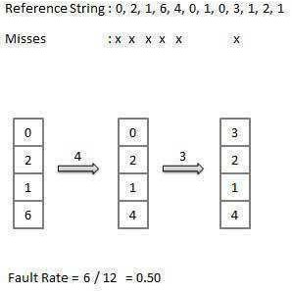

## Fig 3.28 Optimal Page algorithm Least Recently Used (LRU) algorithm

* + Page which has not been used for the longest time in main memory is the one which will be selected for replacement.
  + Easy to implement, keep a list, replace pages by looking back into time.

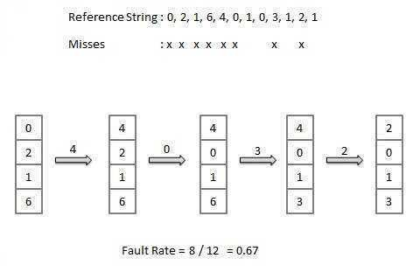

## Fig 3.29 Least Recently Used (LRU) algorithm Page buffering algorithm

* + To get a process start quickly, keep a pool of free frames.
  + On page fault, select a page to be replaced.
  + Write the new page in the frame of free pool, mark the page table and restart the process.
  + Now write the dirty page out of disk and place the frame holding replaced page in free pool.

## Least frequently Used (LFU) algorithm

* + The page with the smallest count is the one which will be selected for replacement.
  + This algorithm suffers from the situation in which a page is used heavily during the initial phase of a process, but then is never used again.

## Most frequently Used (MFU) algorithm

* + This algorithm is based on the argument that the page with the smallest count was probably just brought in and has yet to be used.